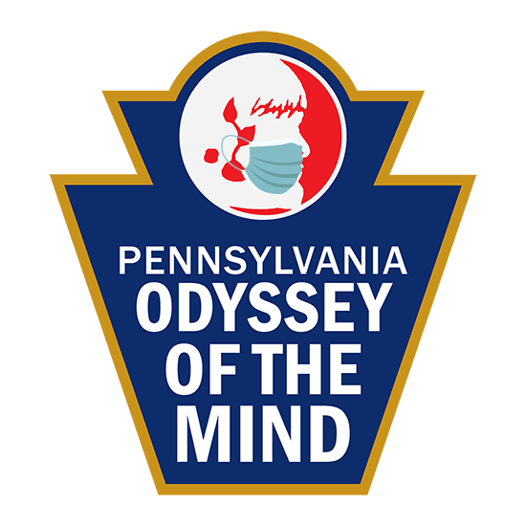
PENNSYLVANIA ODYSSEY OF THE MIND
COVID-19 Guidelines Compliance Form

Long-Term Problem _______________________________________ Division ______________________
Membership Name _____________________________________ Membership Number _____________
City _________________________________________________ State/Prov. PA Country USA .

In order to run a safe and fair competition, we require teams to follow all local, state, and CDC COVID-19 guidelines, including any applicable masking and social distancing guidelines, when preparing for and competing in Pennsylvania Odyssey of the Mind tournaments presented by Creativity Unlimited in Pennsylvania. Per the Program Guide and Virtual Tournament Procedures, teams should not consider putting their health at risk for the sake of their solutions. Submission requirements allow extra time for teams to show the judges specifics about their solutions and to explain elements which might otherwise get lost in a virtual solution. Teams or team-members not following COVID-19 guidelines in solving or presenting their solutions could be subject to a Spirit of the Problem penalty. Please know, judging panels are excited to thoroughly review your submission materials and to understand what you have created.

By signing below, we testify we have followed all COVID-19 local, State and CDC guidelines during the preparation and recording of our submission for a Pennsylvania Odyssey of the Mind tournament presented by Creativity Unlimited in Pennsylvania.
Please use the space below to clarify any actions in your submission which need to be explained.

Coach # 1 ______________________________ Team Member __________________________
Coach # 2 ______________________________ Team Member __________________________
Coach # 3 ______________________________ Team Member __________________________
Team Member __________________________ Team Member __________________________
Team Member __________________________ Team Member __________________________

