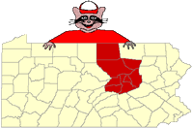 | NCPA Odyssey of the Mind  Regional Tournament 2024-25  Team Fee Form
School Name______________________________________________________________________________________________
Coordinator ID #_____________________________________________________________________________________________
Contact’s Name: __________________________________________________________________________________________
Phone #: ______________________________________ E-Mail __________________________________________________

North Central Team Fees:
$100.00 per team registered for NCPA Regional Tournament.
Deadline: January 25, 2025.
**A late fee of $25.00 will be assessed on any fees postmarked after January 25, 2025.**

List each team that has been registered online for the Regional Tournament under the school’s coordinator ID #. Please use a separate form for each membership/coordinator ID.
Problem # | Problem Name | Division

Send this form and a check (Payable to North Central PA OM) to:

April Hartzel-Lewis
NCPA Odyssey of the Mind
1347 Mansel Avenue
Williamsport, PA 17701

